CL3001
Computer Networks - Lab
Lab 6 & Week-6
Task 1
Objectives:
- To explore the basics of network simulation using network simulators.

In this network, the IP addresses of all PCs will be assigned according to the students’ roll numbers.
Rule:
- The first three octets (192.168.1 / 192.168.2 / 192.168.3) depend on the router’s network.
- The last octet of the IP address will start from the last two digits of the student’s roll number.
- After that, the IP addresses will continue in sequence (increasing order).
For Example
Router 1 Network (192.168.1.0/24)
All PCs connected to Router 1 will have IP addresses:
192.168.1.X
Where:
- X = last two digits of the first student’s roll number
- The next PCs will follow in sequence.
Example:
If the first student’s roll number ends with 16, then:
- First PC → 192.168.1.16
- Second PC → 192.168.1.17
- Third PC → 192.168.1.18
- Fourth PC → 192.168.1.19
So the IP addresses start from the roll number and then continue sequentially.

Router 2 Network (192.168.2.0/24)
All PCs connected to Router 2 will have:
192.168.2.X
If the starting roll number ends with 16, then:
- 192.168.2.16
- 192.168.2.17
- 192.168.2.18
- 192.168.2.19
Again, the sequence continues in increasing order.

Router 3 Network (192.168.3.0/24)
All PCs connected to Router 3 will have:
192.168.3.X
Starting from the last two digits of the roll number and continuing in sequence.

Router 4 Network (192.168.4.0/24)
All PCs connected to Router 4 will have:
192.168.4.X
Starting from the last two digits of the roll number and continuing in sequence.

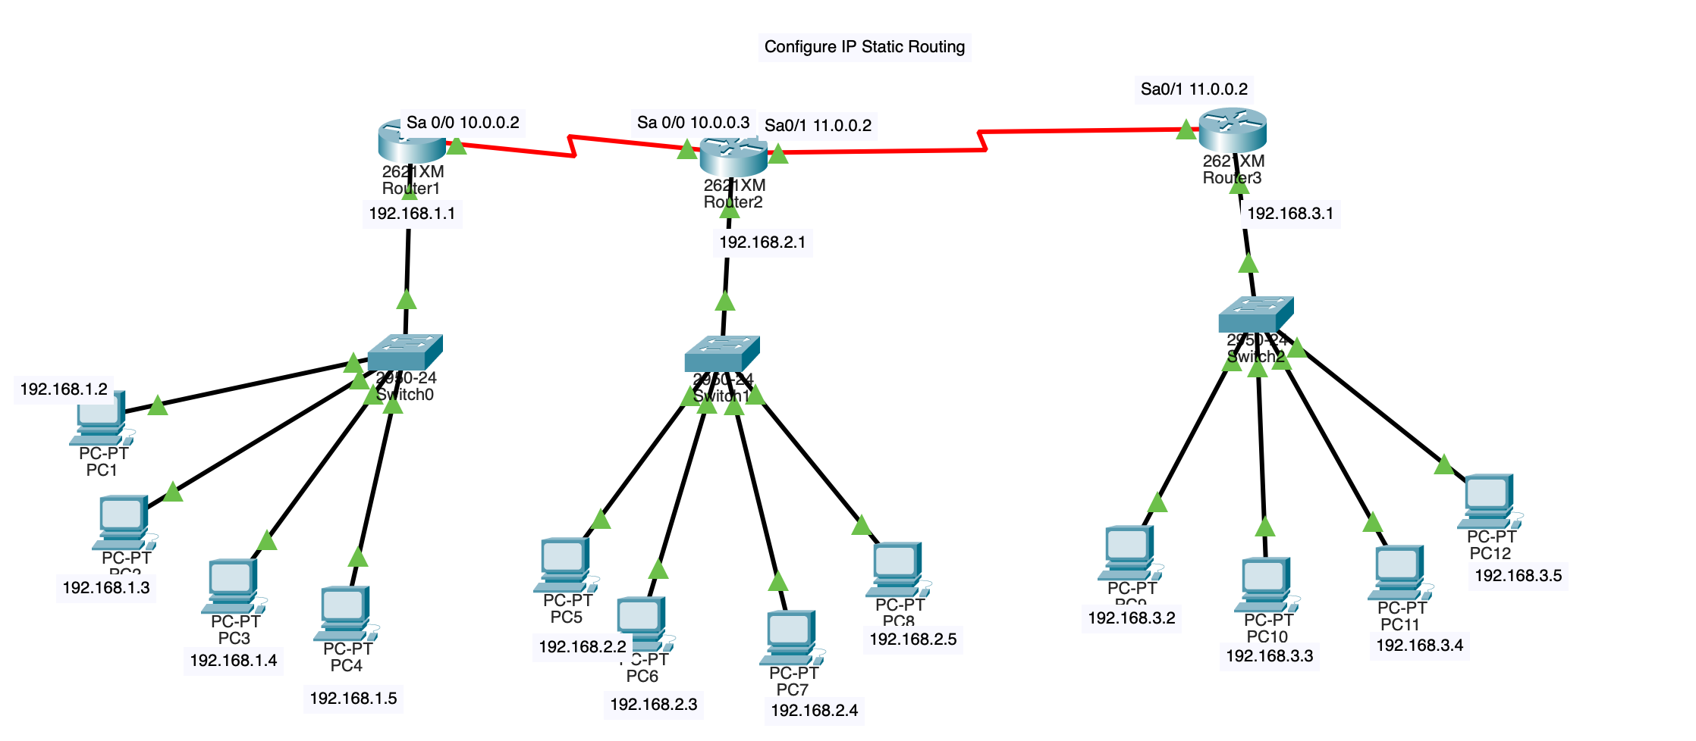

Step 1: PC IP Configuration
For every PC in the network (such as PC1, PC2, PC3, and PC4), you must manually set up the IP address, subnet mask, and default gateway.

IP Configuration of the PC1
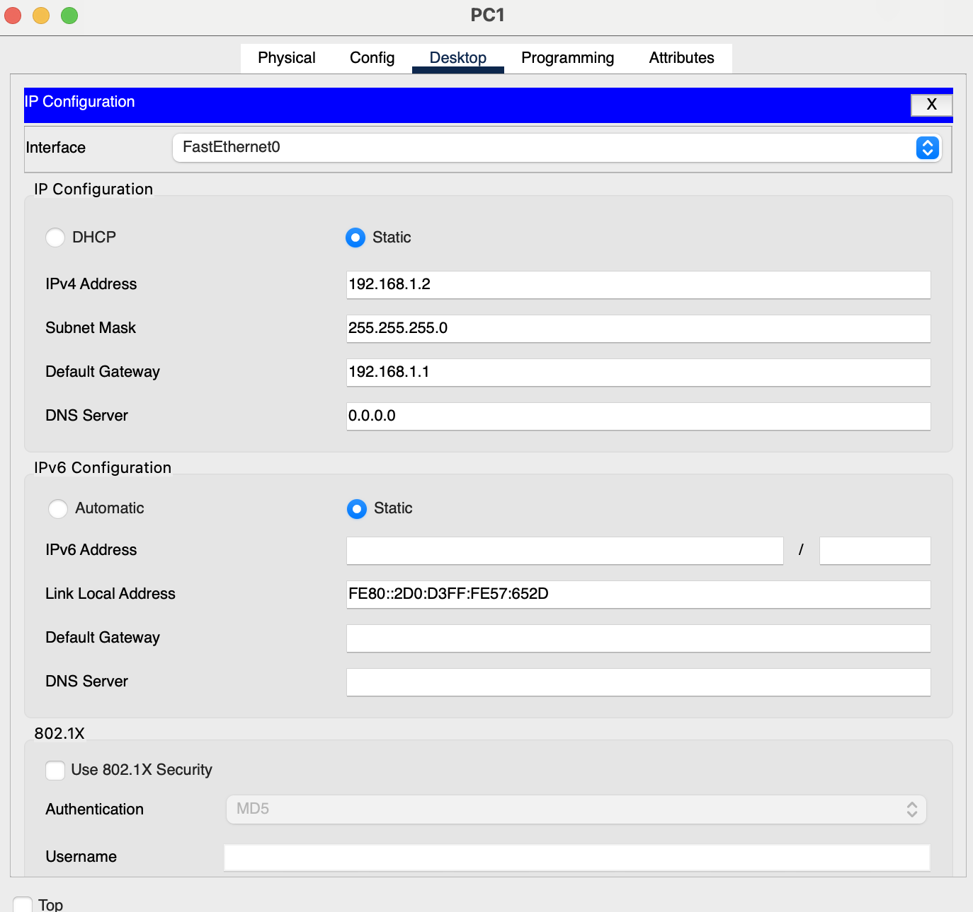
IP Configuration of the PC2:
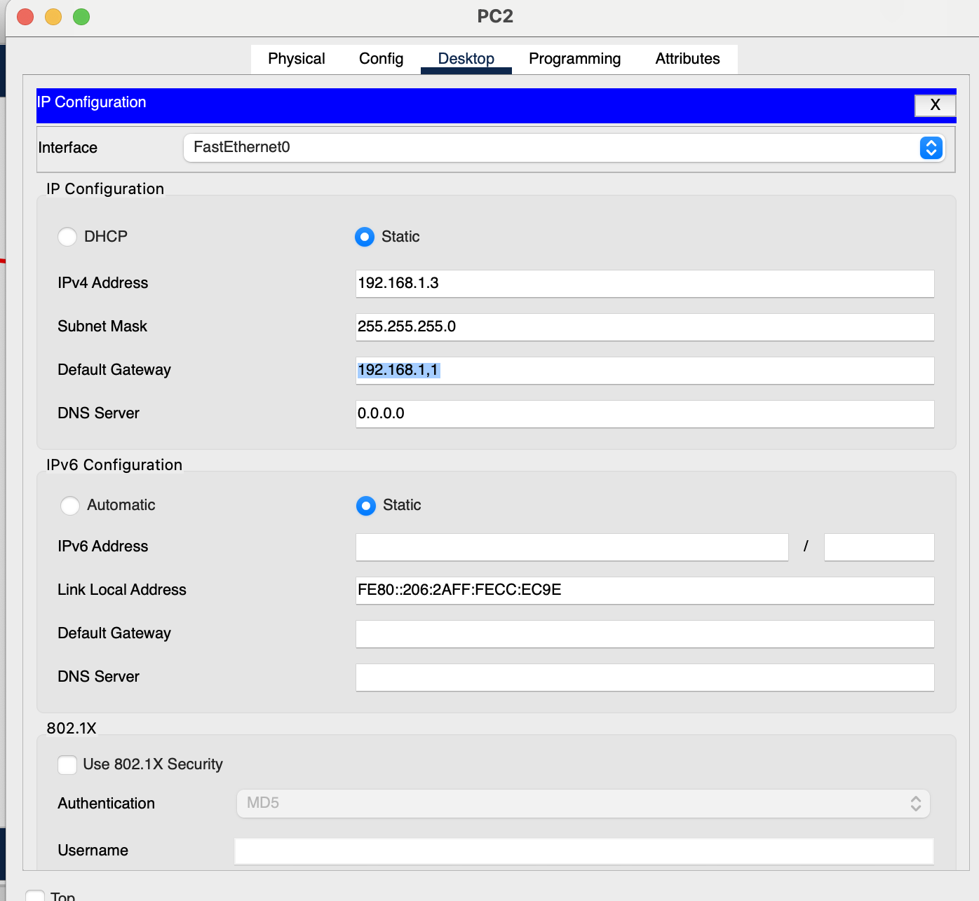
IP Configuration of the PC3
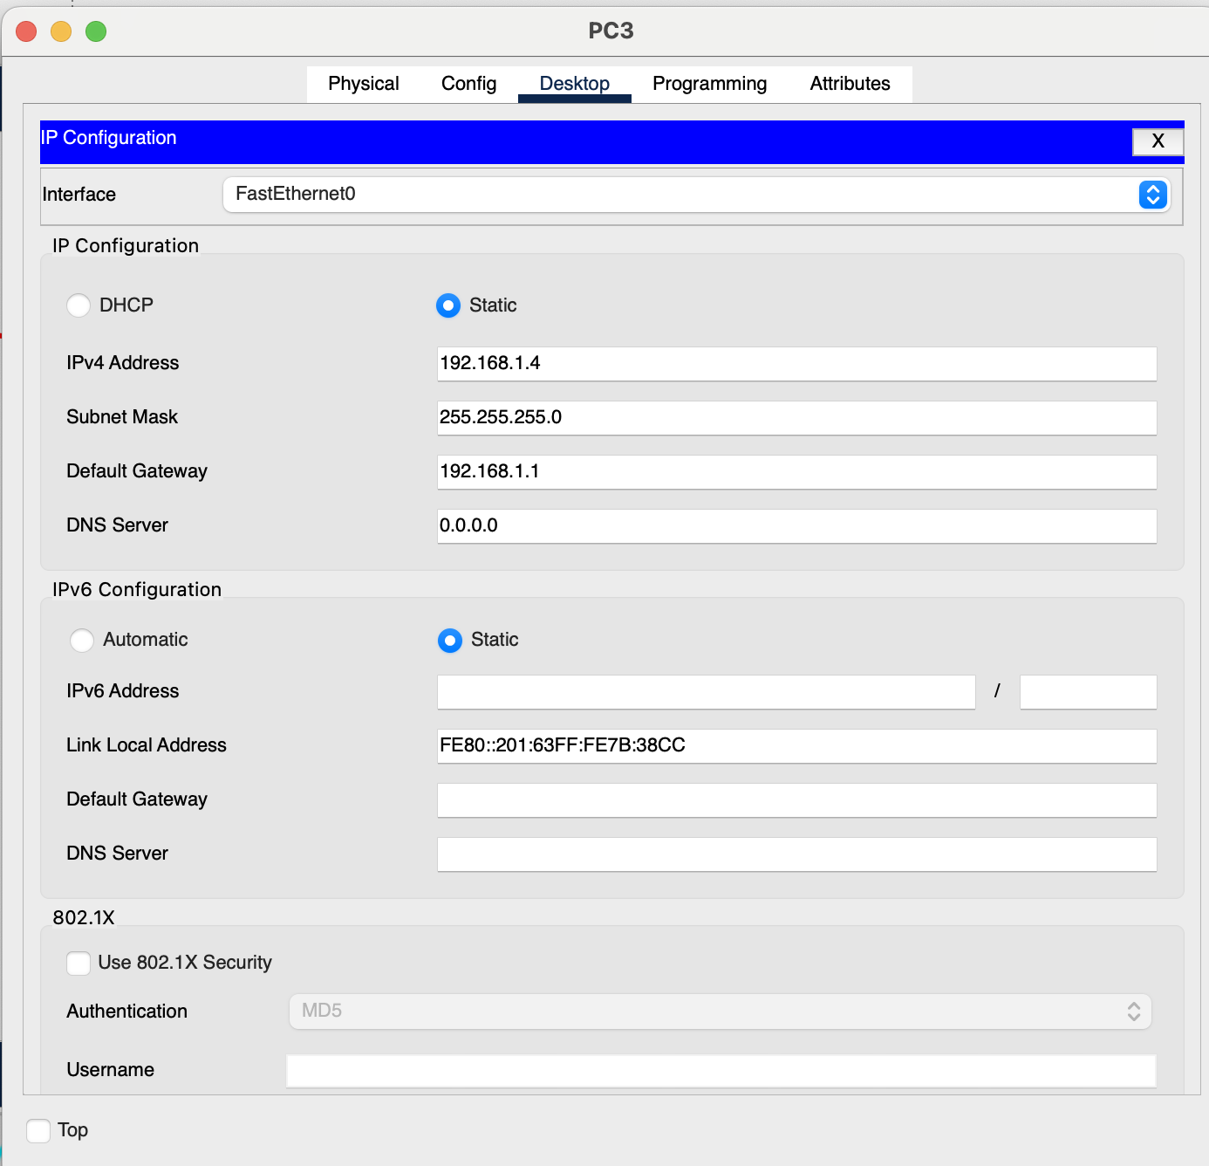
IP Configuration of the PC4
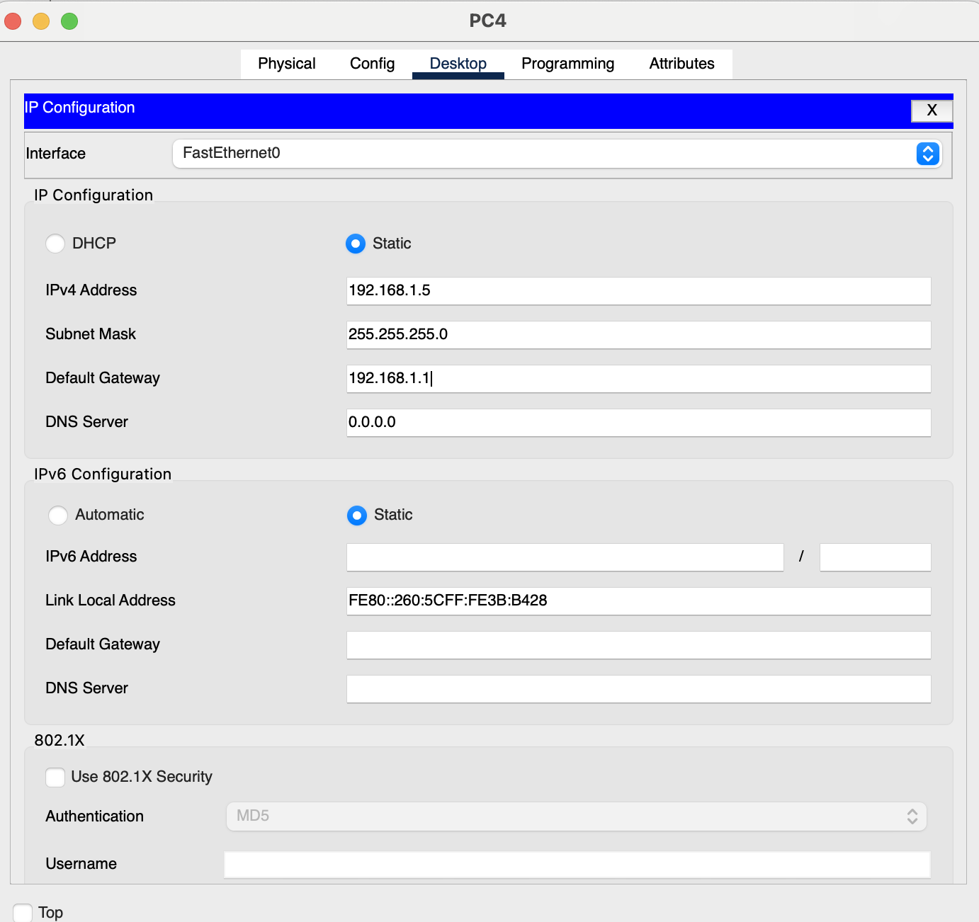

Step 2: Configuring Router Connections
Configure the serial interfaces (e.g., Serial 0/0 and Serial 0/1) with the appropriate IPv4 addresses and ensure the "Port Status" is set to "On".
Serial 0/0 Port Of the Router 1 connect Serial 0/1 of router 2

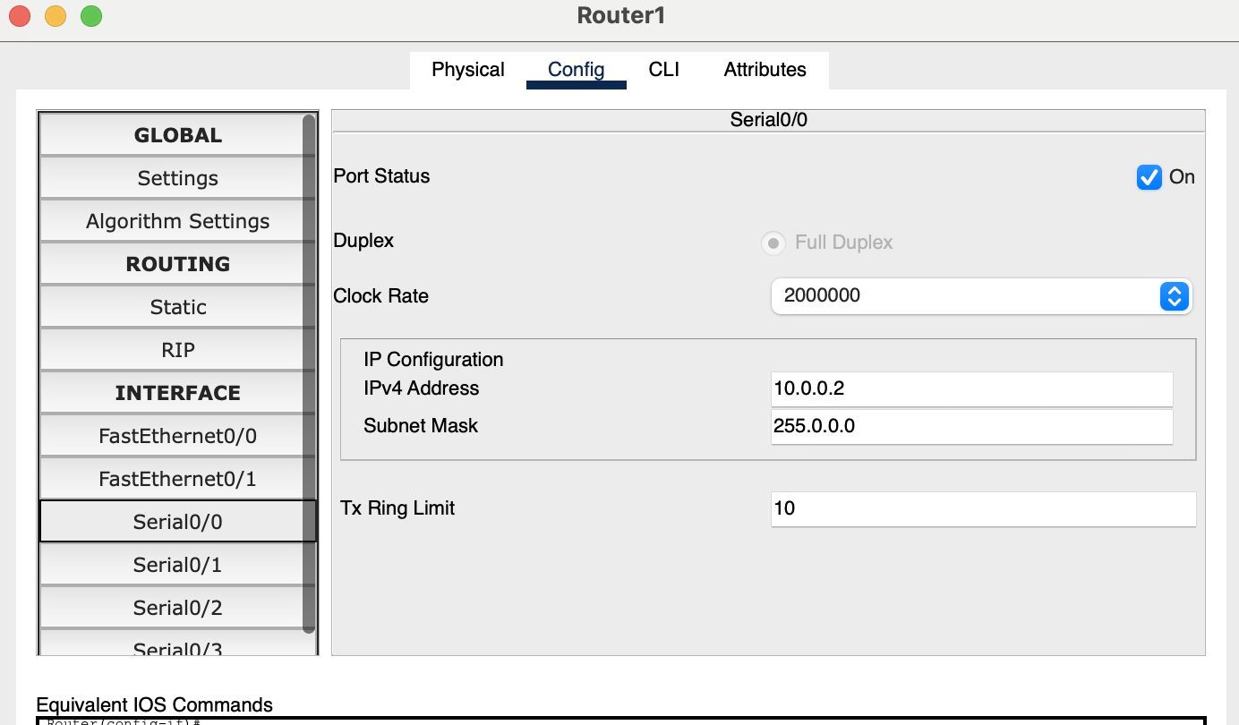
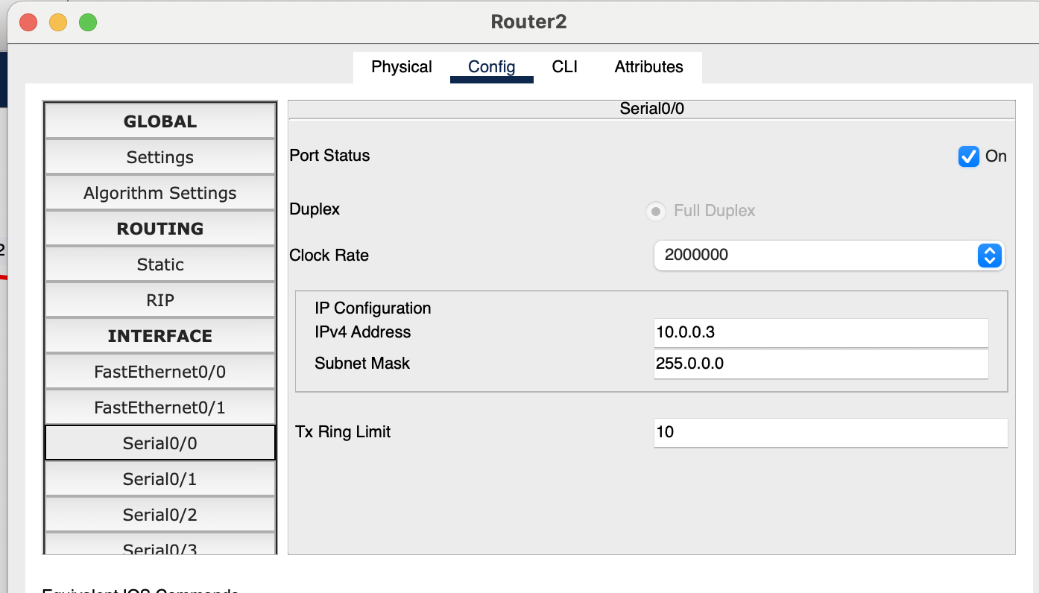
Serial 0/1 Port Of the Router 2 connect Serial 0/1 of router 3
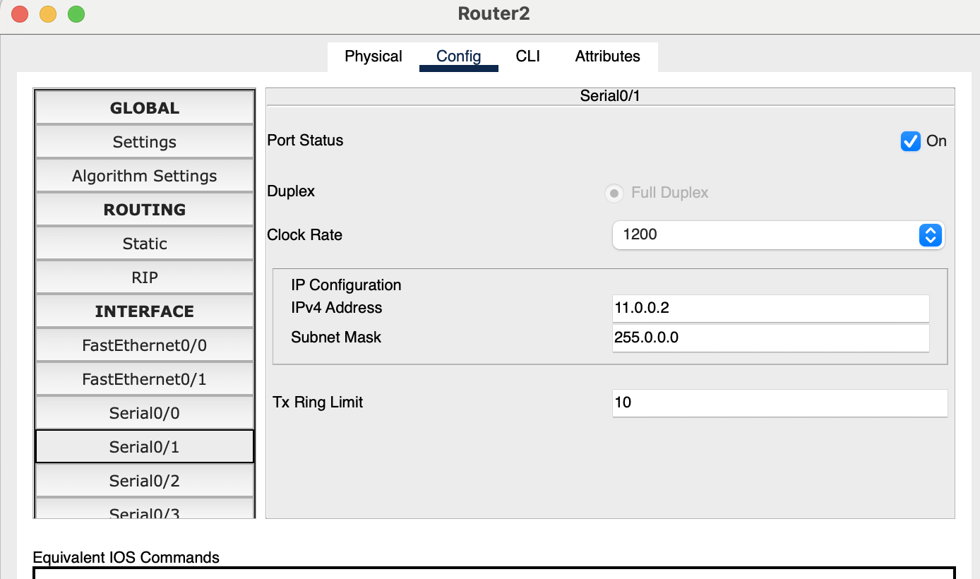
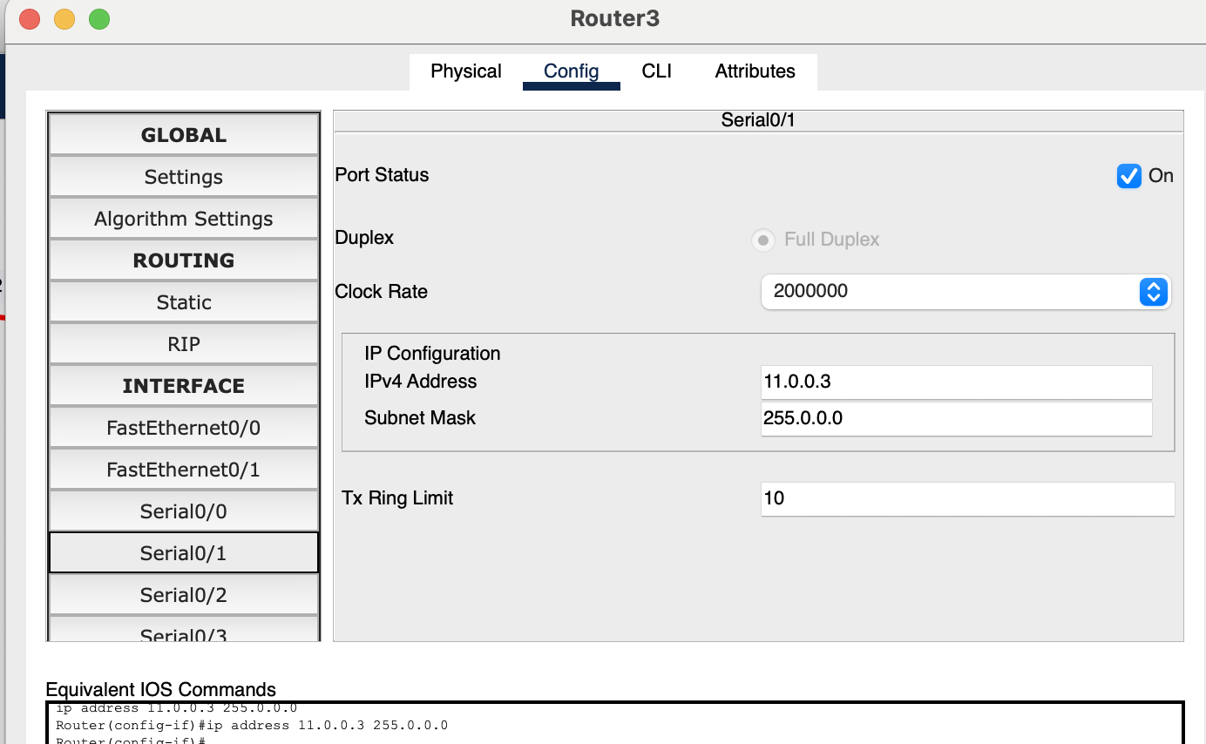
Step 3: Implementing Static Routing
- To allow data to travel between different network segments (for example, from PC1 to PC5 through PC12), you must tell each router where to send traffic that is not on its local network.
- For each router, add the network address, subnet mask, and the "Next Hop" IP address (the IP of the neighboring router's interface). This creates a manual map so the routers know how to reach the remote networks
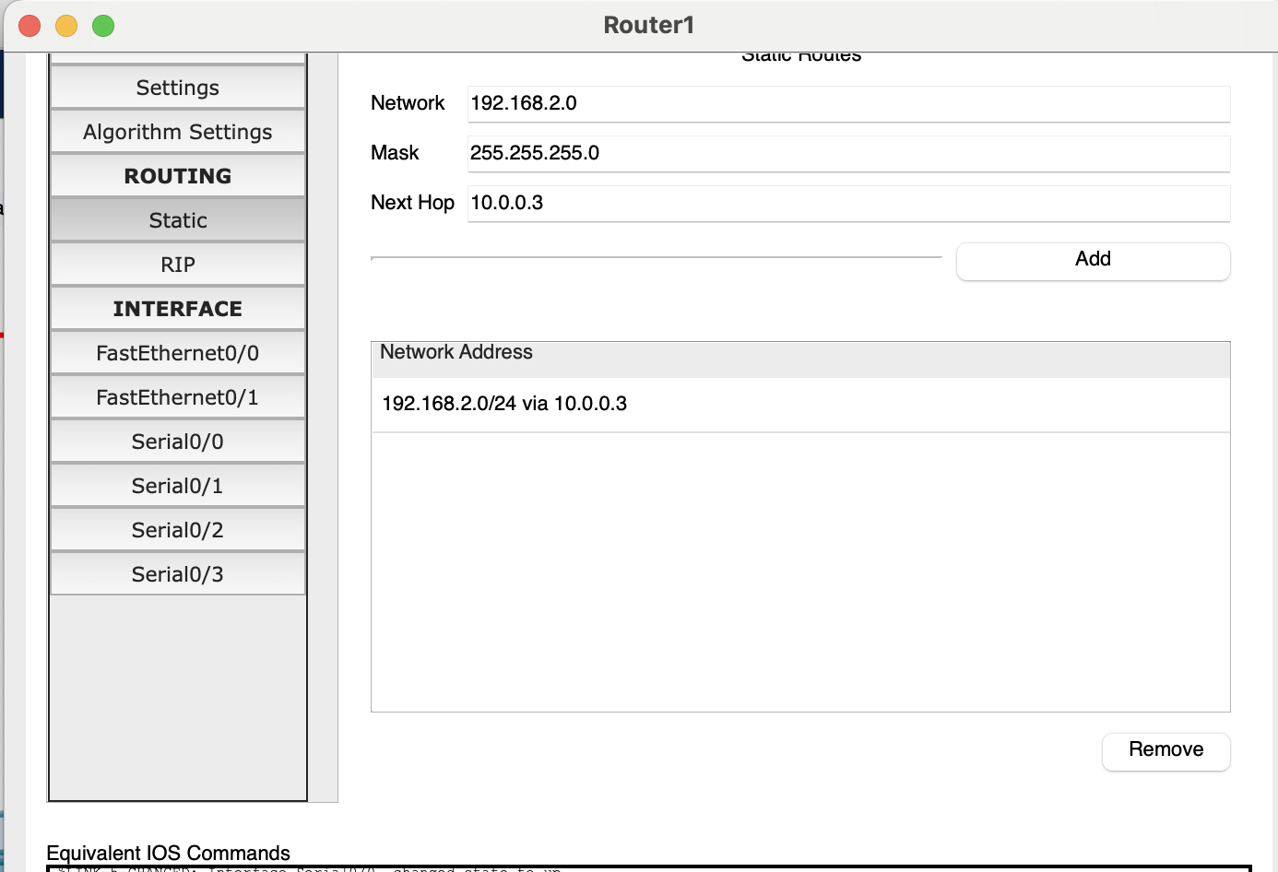
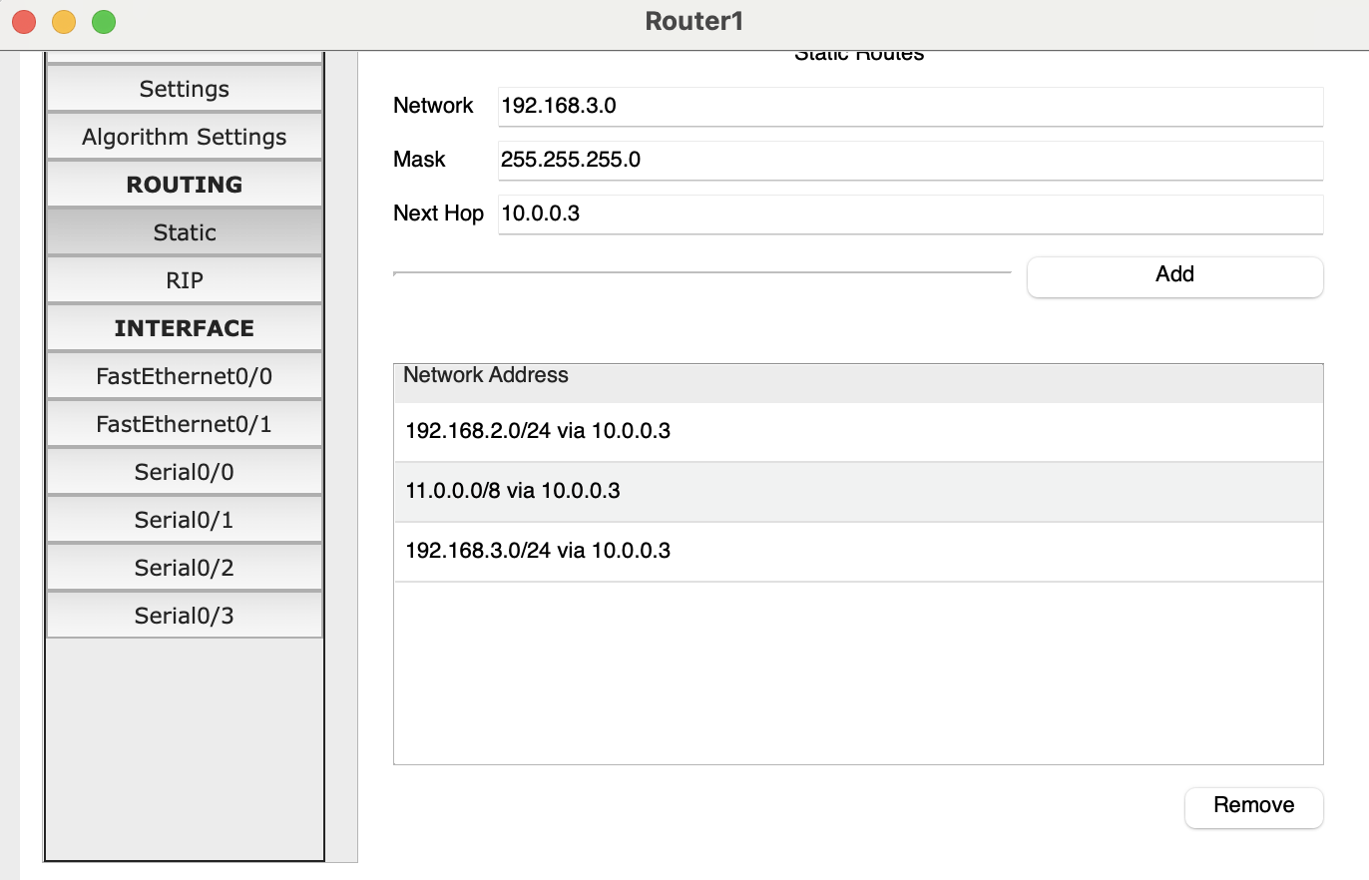

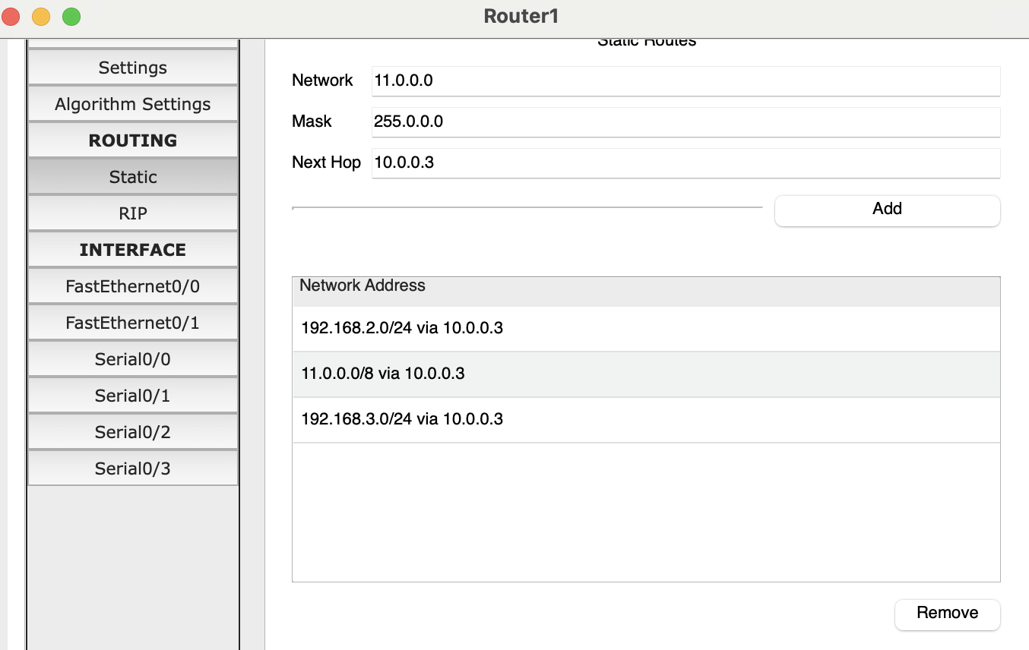

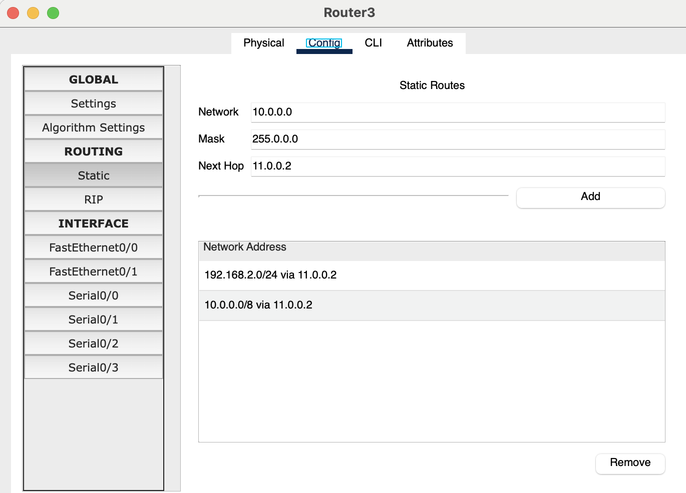

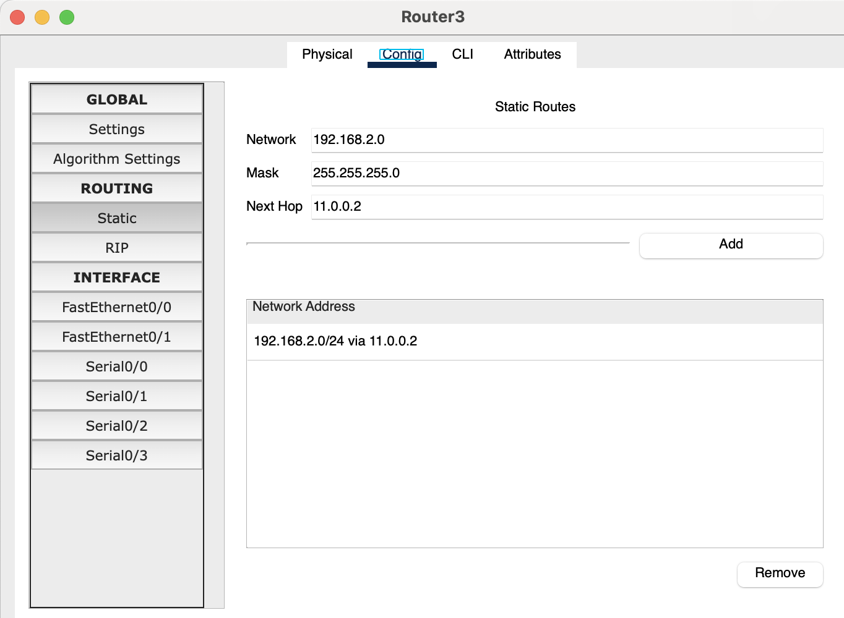
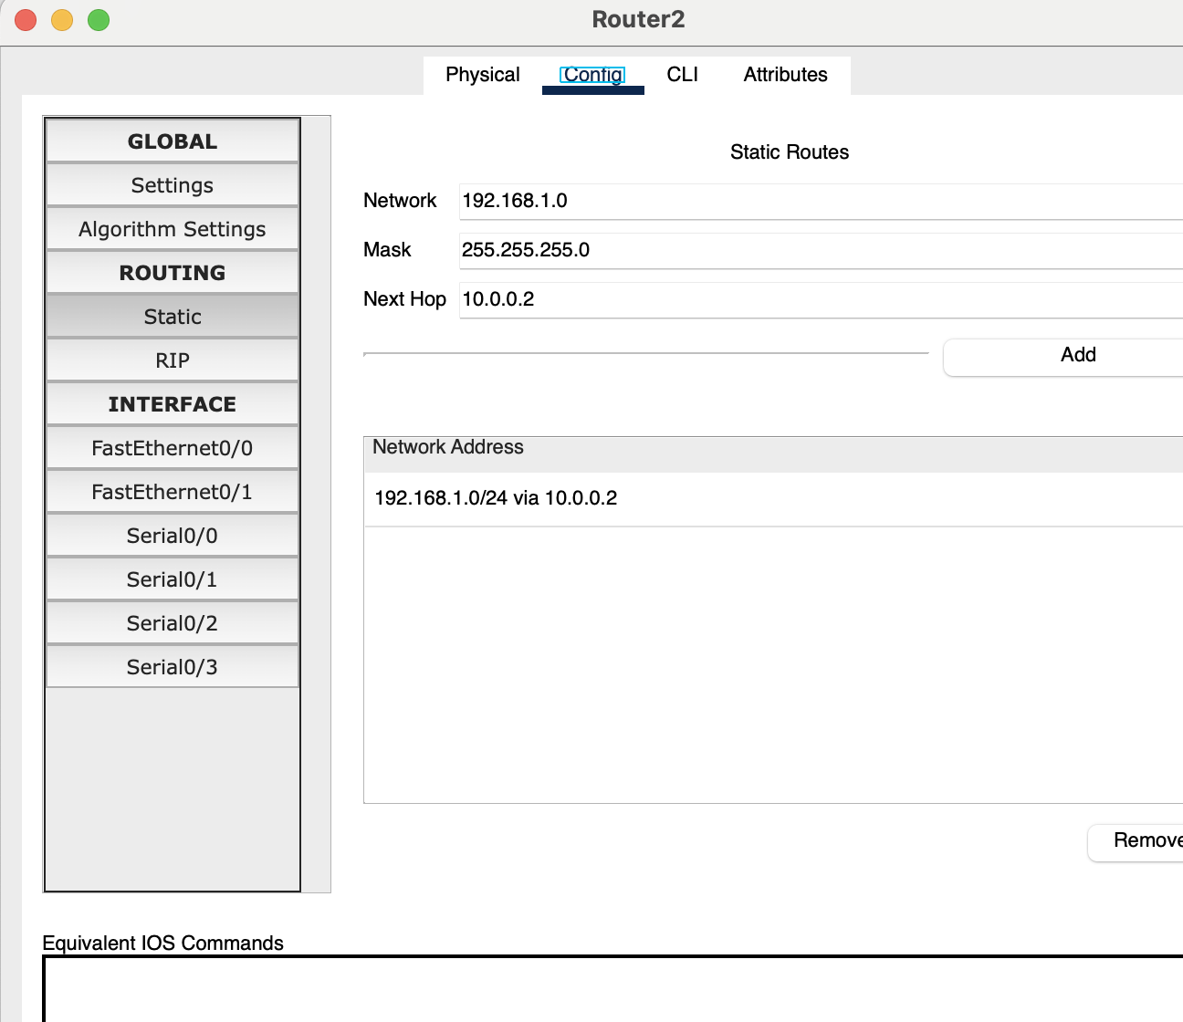
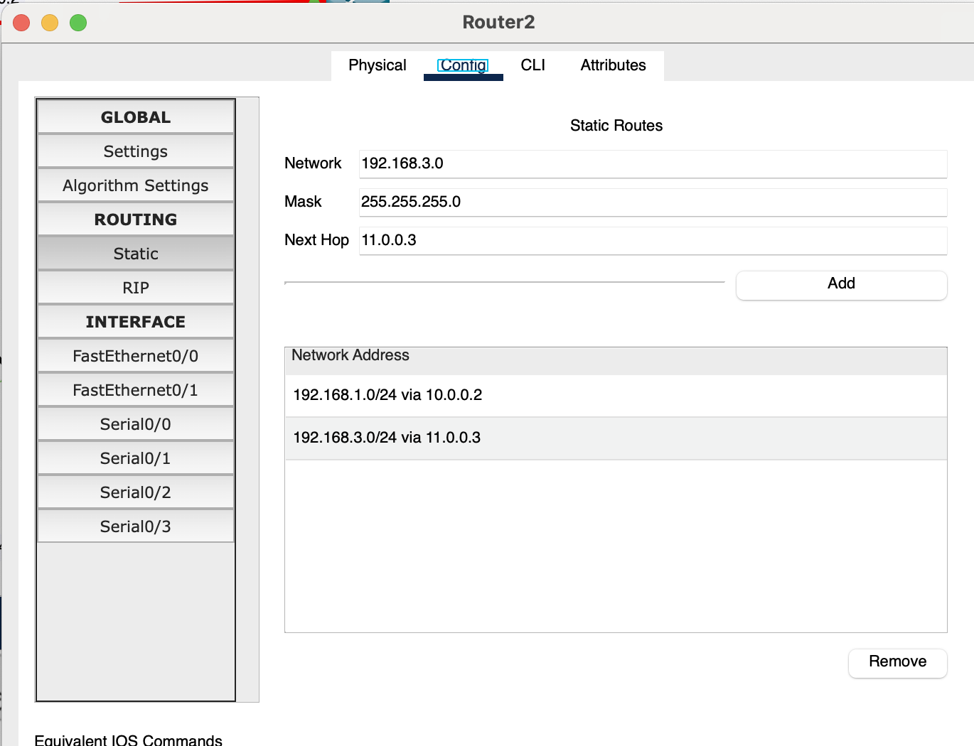

Step 4: Verification (Packet Transfer)

Then Packet Transfer from Pc 2 to PC 11 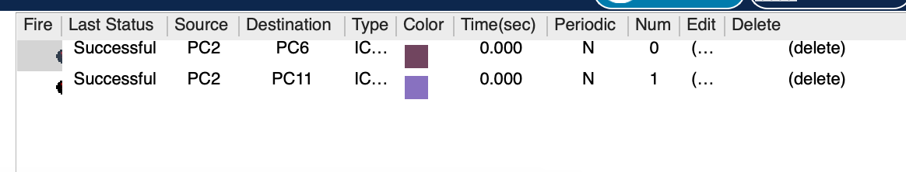

Configuration using CLI

-----------------------------------------------------Router 1-----------------------------------------
Router>enable
Router#config t
Enter configuration commands, one per line. End with CNTL/Z.
Router(config)#int fa 0/0
Router(config-if)#ip add 192.168.1.1 255.255.255.0
Router(config-if)#no shut

Router(config-if)#
%LINK-5-CHANGED: Interface FastEthernet0/0, changed state to up

%LINEPROTO-5-UPDOWN: Line protocol on Interface FastEthernet0/0, changed state to up

Router(config-if)#ex
Router(config)#int s 0/0
Router(config-if)#ip add 10.0.0.2 255.0.0.0
Router(config-if)#no shut

%LINK-5-CHANGED: Interface Serial0/0/0, changed state to down
Router(config-if)#ex

Router(config)#ip route 192.168.2.0 255.255.255.0 10.0.0.3
Router(config)#ip route 192.168.3.0 255.255.255.0 10.0.0.3
Router(config)#ip route 11.0.0.0 255.0.0.0 10.0.0.3
Router(config)#ex
Router#

-----------------------------------------------------Router 2----------------------------------------------
Router>enable
Router#conf t
Enter configuration commands, one per line. End with CNTL/Z.
Router(config)#int fa 0/0
Router(config-if)#ip add 192.168.2.1 255.255.255.0
Router(config-if)#no shut
Router(config-if)#
%LINK-5-CHANGED: Interface FastEthernet0/0, changed state to up
%LINEPROTO-5-UPDOWN: Line protocol on Interface FastEthernet0/0, changed state to up
Router(config-if)#ex
Router(config)#int s 0/0
Router(config-if)#ip add 10.0.0.3 255.0.0.0
Router(config-if)#no shut
%LINK-5-CHANGED: Interface Serial 0/0, changed state to up
Router(config-if)#ex
Router(config)#int s 0/1
Router(config-if)#ip add 11.0.0.2 255.0.0.0
Router(config-if)#no shut
%LINK-5-CHANGED: Interface Serial 0/1, changed state to down
Router(config-if)#ex

Router(config)#ip route 192.168.1.0 255.255.255.0 10.0.0.2
Router(config)#ip route 192.168.3.0 255.255.255.0 11.0.0.3
Router(config)#ex
Router#

-----------------------------------------------------Router2----------------------------------------------
Router>enable
Router#conf t
Enter configuration commands, one per line. End with CNTL/Z.
Router(config)#int fa 0/0
Router(config-if)#ip add 192.168.3.1 255.255.255.0
Router(config-if)#no shut

Router(config-if)#
%LINK-5-CHANGED: Interface FastEthernet0/0, changed state to up

%LINEPROTO-5-UPDOWN: Line protocol on Interface FastEthernet0/0, changed state to up
Router(config-if)#ex
Router(config)#int s 0/0
Router(config-if)#ip add 11.0.0.3 255.0.0.0
Router(config-if)#no shut

%LINK-5-CHANGED: Interface Serial0/0/0, changed state to up

Router(config-if)#ex
Router(config)#ip route 192.168.2.0 255.255.255.0 11.0.0.2
Router(config)#ip route 192.168.1.0 255.255.255.0 11.0.0.2
Router(config)#10.0.0.0 255.255.255.0 11.0.0.2
Router(config)#ip route 10.0.0.0 255.0.0.0 11.0.0.2
Router(config)#ex
Task 2

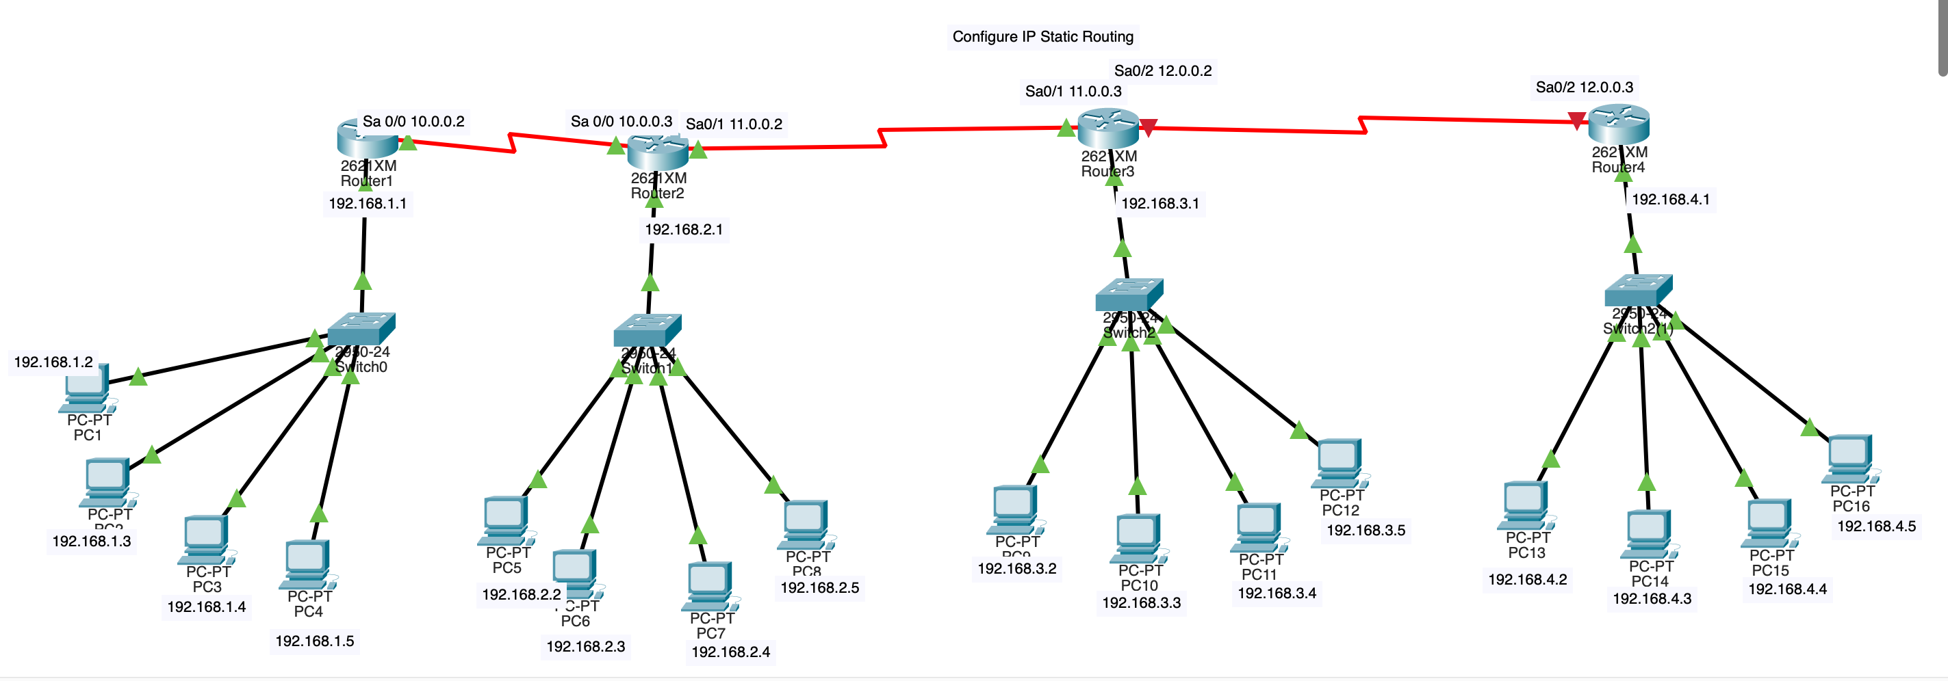
------------------------------------------------------------------------------------------------------------------------------------------------------------------
Note:
Read the whole manual first then understand it and note down what you understood is the task you must do in the submission file. Use your own words to give step by step instructions which you are going to follow. Apply this lab task in time and follow each step. If faced with any issue make sure to ask, any questions just raise your hand and call your lab instructor for guidance.
“ Let the beauty of what you love, be what you do ” ~ Rumi

